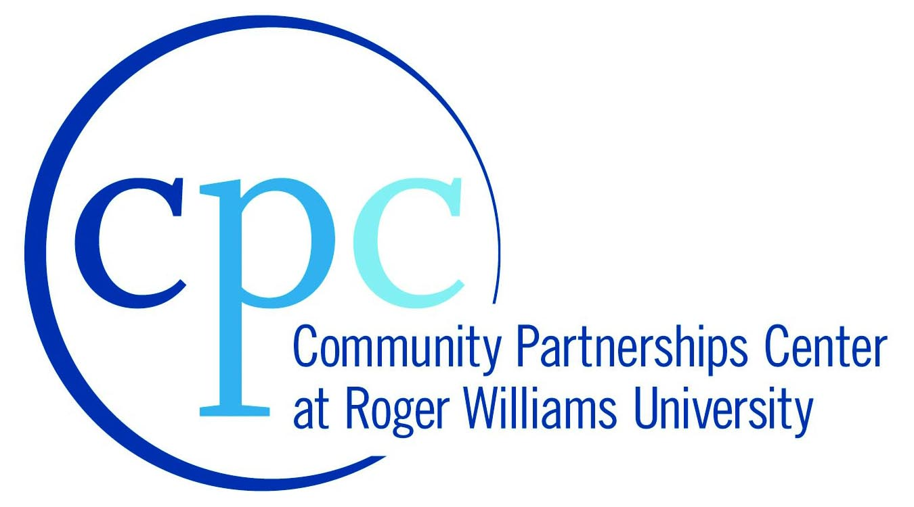
Rhode Island Economic Development Corporation (RIEDC)
Roger Williams University Community Partnerships Center (CPC)

City of Woonsocket, R.I.

Overview
RIEDC, as part of its economic development mission and in partnership with the Office of the Governor of the State of Rhode Island, supports targeted economic development and community building initiatives within the five core communities of Providence, Woonsocket, West Warwick, Pawtucket and Central Falls. The RWU CPC will partner with RIEDC and with local elected officials and community leaders to formulate and support academic programs consistent with the problem-solving interests of the RIEDC and the core communities. In Woonsocket, RWU will assist local revitalization efforts in Downtown Woonsocket, focused along Main Street, while providing a setting in which students may gain “real-world” technical experience through ongoing curriculum-based projects.

City of Woonsocket: Phase 1 – Fall 2012
Through the Issues and Elements in Community Development course at RWU, 10 community development students will collaborate with the City’s Economic Development department and local nonprofit organizations to create a plan for revitalization activities in Downtown Woonsocket, focused along Main Street.
- Outcome/Deliverable: The results of the students work will be compiled into a final report with recommendations that will be delivered to the City and key stakeholder organizations in December. This information will be vital to future City and RWU efforts for planning, design and implementation.

Through the Historic Rehabilitation Workshop course at RWU, a four-student, graduate-level team of architecture and historic preservation students will create a historic rehabilitation plan for the Longley Building in Woonsocket, a building the City has deemed crucial for redevelopment as a gateway to the Downtown, City Hall and Blackstone Valley Heritage Corridor headquarters.
- Outcome/Deliverable: The Rehabilitation Plan for the building will be delivered in December and will include research and recommendations that have never been prepared for this building: existing conditions assessment, rehabilitation scope of work, cost estimates, draft application for federal rehabilitation tax credits and specifications for key elements of the project. The City and the owner can use this as the basis to fund the next phase of feasibility and design for the rehabilitation and reuse of the building.

Through the Small Business Institute course at RWU, a team of students will collaborate with the City and local arts groups to assess the vital theater and entertainment programs and assets that already exist. They will then research national best practices and develop a marketing plan for downtown Woonsocket.
- Outcome/Deliverable: The results of the students work will be compiled into a marketing plan with concrete recommendations for building the economic impact of arts and entertainment events through connections to local restaurants and other attractions.

City of Woonsocket: Phase 2 – Spring 2012
Based on the outcomes from the work in Fall 2012 and the needs identified by the communities and the State, RWU will continue its work in collaboration with local partner organizations and agencies, using:
- Up to two academic courses fully engaged in the RIEDC project (Urban Design, Historic Preservation Planning)
- Up to two academic courses partially engaged in RIEDC Project (Community Development; Business Special Topics; Course)
- Two graduate assistants tasked to project coordination/support
- Two senior business school interns focused on direct business support to local organization

City of Woonsocket: Phase 3 – Summer 2012
Based on the outcomes from the work in Fall 2012 and Spring 2013 as well as the needs identified by the communities and the State, RWU will continue its work in collaboration with local partner organizations and agencies, using:
- An Urban Redevelopment special topics class to be fully engaged in the RIEDC project
- A four-person team of students from the Small Business Institute course
- Two graduate assistants tasked to project coordination/support
- One senior business school intern focused on direct business support to local organization

