Hassenfeld Student Leadership Fellowship Program
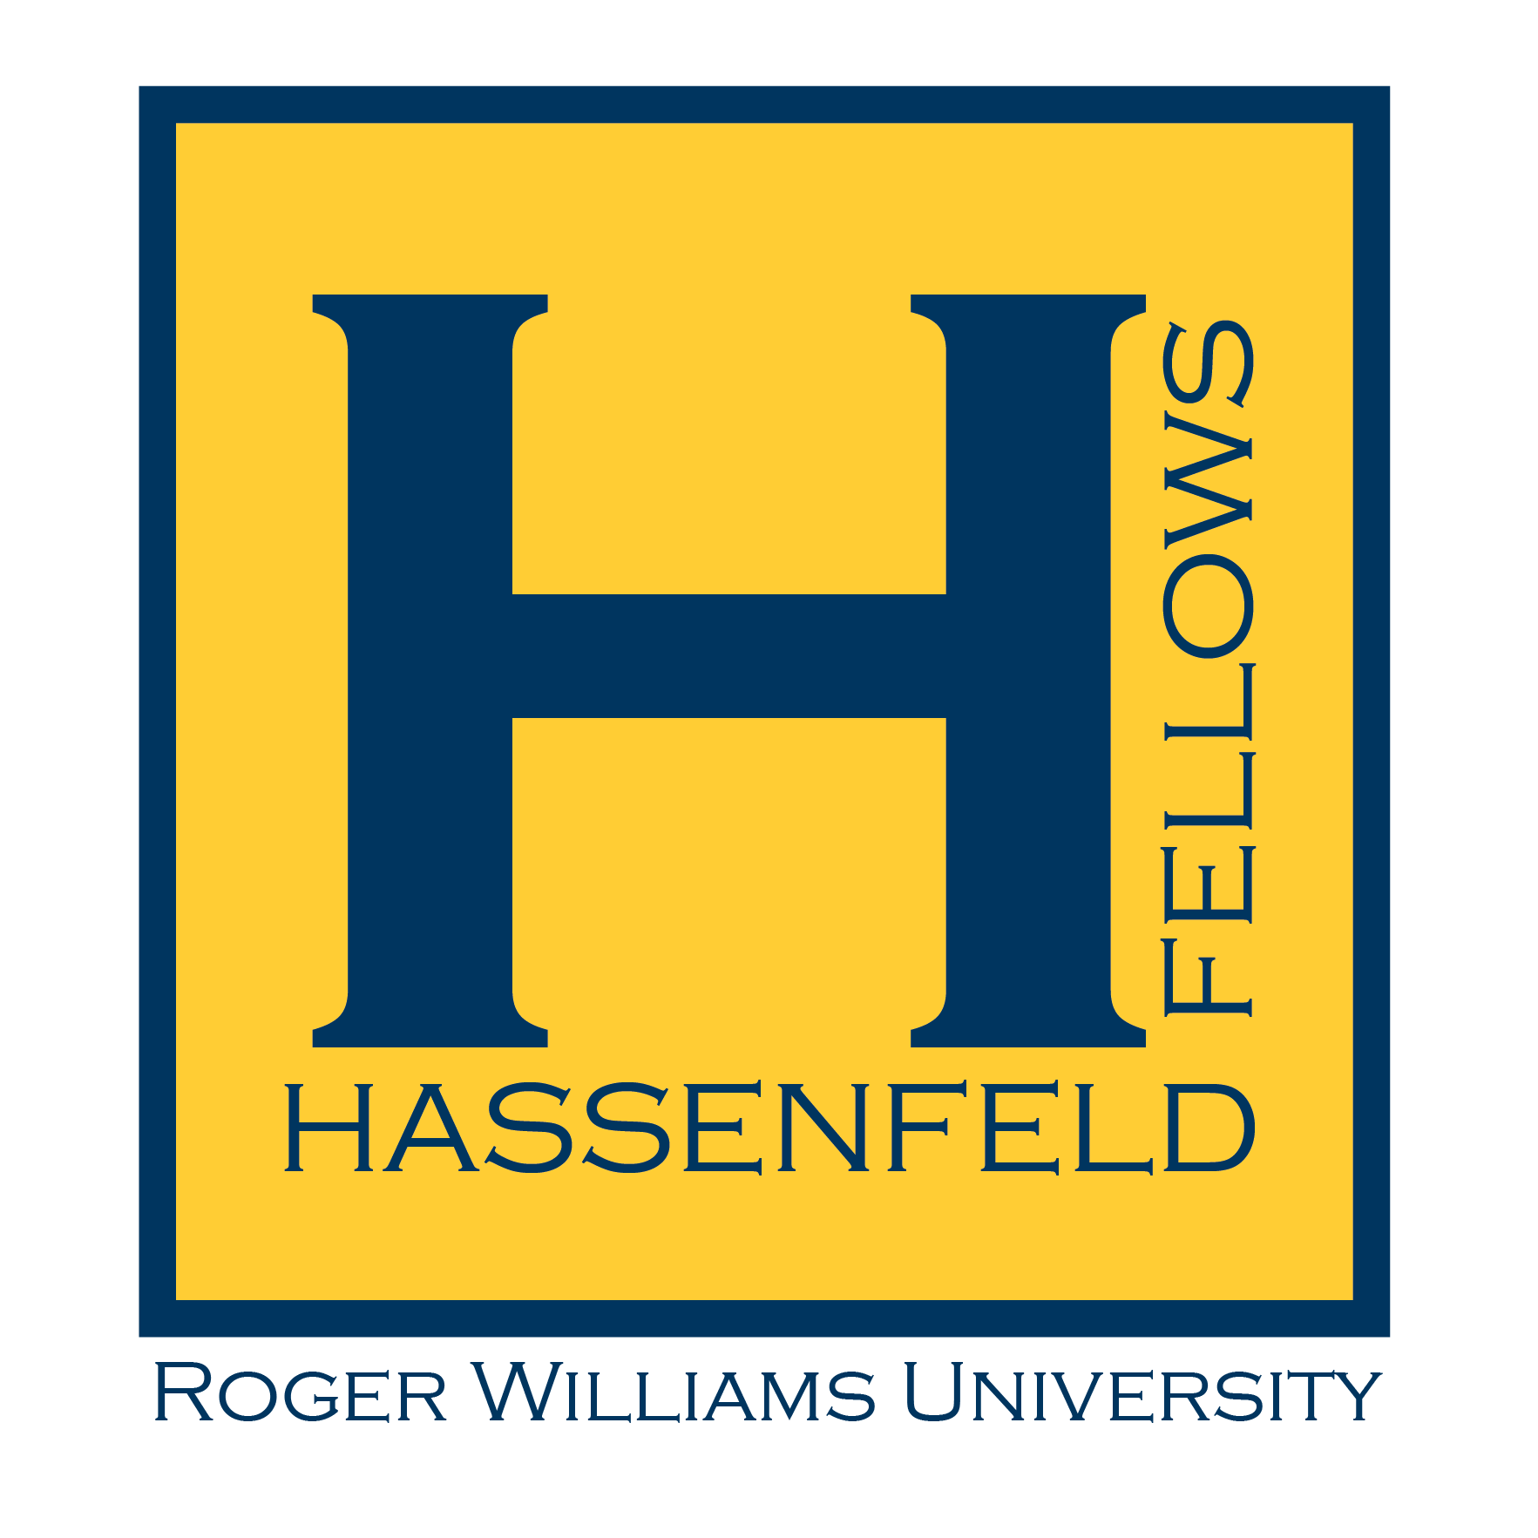
This program is made possible through a $500,000 gift from Hassenfeld Family Initiatives LLC, which established the Hassenfeld Projects – an intensive, three-year initiative to expand and enhance innovative work in experiential education.
The grant builds on RWU’s growing cadre of experiential programs that prepare students to meet the demands of today’s employers while building skill sets in areas such as economic development, sustainability and social justice.
The Hassenfeld Projects will encompass and enhance a variety of existing community-focused programs in which students work on real-world projects defined by the University’s community partners.

2017-2018
Roger Williams University

The Hassenfeld Student Leadership Fellowship Program (HFP) provides opportunities for RWU students who are deeply interested in community engagement to build their skills, increase their personal capacity to affect change, and have more impact on the community. The program is competitive and is open to RWU students from all disciplines and programs.
All HFP projects benefit the local or global community while providing the Fellows with experience in real-world projects that deepen their academic, civic, and human experiences. Selected Fellows will “strengthen society through engaged teaching and learning” by partnering with community-based organizations, locally and globally, to tackle the issues challenging our communities. Fellows will benefit from a structured program that can transform students into public leaders while addressing persistent community needs in a systemic way. This will be achieved by participation in a variety of leadership and capacity building activities as well as direct and indirect service to the community.
Fellows may propose their own program/project based on their interests or current activities or ask for assistance in finding a placement. They also may be nominated by a faculty or staff member who recognizes the student’s commitment and involvement in a community based issue.
HFP participants will benefit from participation in the program in a variety of ways including:
- Work within one’s passion, interests, and desired career path.
- Develop leadership, management, and professional skills.
- Understand the complexities of community issues as well as the community problem solving process.
- Work with a mentor – a professional at RWU or at a community agency – who will contribute to the fellow’s work and growth by providing important feedback and guidance.
- Gain hands-on experience that can be highlighted on the student’s resume or graduate school application.
Fellowship project/program examples:
- Working on a CPC project team
- Coordinating travel and project logistics for FIMRC
- Leading weekly Lego Robotics activities at the Bristol Recreation Center
- Facilitating public health research with RWU faculty benefiting Bristol Health Equity Zone
- Working with a non-profit to coordinate RWU volunteers regularly
- Committing a specified number of hours in service to a non-profit organization or program that benefits a civic purpose.
- Coordinating the Feinstein Community Connections program
Qualifications for Fellows:
- Experience with community service, service-learning and/or civic engagement programs or activities.
- Demonstrated track record of high level of responsibility, proactivity and ability to work in functional partnerships.
- Demonstrated ability to collaborate with students, faculty, staff, and community partners.
- Comfortable managing multiple tasks.
- Strong oral and written communication skills; will feel comfortable talking with students, faculty, staff and alumni, with a focus on communicating the vision for the Center with regularity and ease.
Application Instructions
- Download and complete the HFP Application Form.
  - Deadline for summer 2018 May 15, 2018
  - Deadline for 2018-2018 Academic Year May 15, 2018
  - Deadline for fall only 2018 program July 15, 2018
  - Deadline for spring only 2019 program December 1, 2018
- The most qualified candidates will be interviewed either in person or via Skype depending on availability.
- Additional applications may be accepted depending on availability.
Have guestions about the Hassenfeld Student Leadership Fellowship Program? Contact KC Ferrara, Director of the Feinstein Center for Service Learning and Community Engagement at kferrara@rwu.edu or 401-254-3765.

Summer 2018 Program
May 14 – August 17, 2018

Program requirements:
- Be a full-time or part-time student (undergraduate or graduate) enrolled at RWU.
- Work directly with or on behalf of a non-profit organization or government agency, with priority given to projects that focus impact on the Rhode Island and its residents.
- Complete 120 hour term (includes service, meetings, training at RWU and at the partnering site)
- Fellows may work during academic breaks in the winter, spring and summer with program administrator approval.
- Accept no additional pay (i.e. payroll, work study, etc.) for this project/program.
- Provide summary at end of term detailing service work and outcomes. This may be in any format including written report, photo essay, short film, field journal, etc.
Compensation
Fellows will receive $1,500 scholarship after the completion of 120 hours.

Full Academic Year Program
August 29, 2018– May 17, 2019

Program requirements:
- Be a full-time or part-time student (undergraduate or graduate) enrolled at RWU.
- Work directly with or on behalf of a non-profit organization or government agency, with priority given to projects that focus impact on the Rhode Island and its residents.
- Complete 240 hour term (includes service, meetings, training at RWU and at the partnering site)
- Fellows may work during academic breaks in the winter, spring and summer with program administrator approval.
- Accept no additional pay (i.e. payroll, work study, etc.) for this project/program.
- Participate in day-long orientation/leadership retreat before the start of each semester.
- Attend monthly HFP meetings which will focus on skill building and current topics relevant to community-based work such as reflection, social justice, cultural competency, writing for social change.
- Provide summary at end of term detailing service work and outcomes. This may be in any format including written report, photo essay, short film, field journal, etc.
- Participate in public events celebrating community engaged scholarship such as Community Engagement Celebration and SASH as an exhibitor.
Compensation
Fellows will receive $3,000 scholarship. $1,500 will be distributed after the completion of 120 hours and again after the completion of an additional 120 hours.

Half Academic Year Program
Fall: August 29 – December 18, 2018
Spring: January 23 – May 17, 2019

Program requirements:
- Be a full-time or part-time student (undergraduate or graduate) enrolled at RWU.
- Work directly with or on behalf of a non-profit organization or government agency, with priority given to projects that focus impact on the Rhode Island and its residents.
- Program term: Complete 120 hour term (includes service, meetings, training at RWU and at the partnering site)
- Fellows may work during academic breaks in the winter, spring or summer with program administrator approval.
- Accept no additional pay (i.e. payroll, work study, etc.) for this project/program.
- Participate in day-long orientation/leadership retreat before the start of term.
- Attend monthly HFP meetings which will be focused on skill building and current topics relevant to community-based work such as reflection, social justice, cultural competency, writing for social change.
- Provide summary at end of term detailing service work and outcomes. This may be in any format including written report, photo essay, short film, field journal, etc.
- Participate in public events celebrating community engaged scholarship such as Community Engagement Celebration and SASH as an exhibitor.
Compensation
Fellows will receive $1,500 scholarship at scholarship after the completion of 120 hours of service.
Hassenfeld Fellows Program Application
- Full Legal Name: _______________________________________________
- Preferred first name: _______________________________________________
- RWU Student ID#: _______________________________________________
- Home Address: _______________________________________________
- City, State, Zip: _______________________________________________
- Best Telephone #: _______________________________________________
- Email address (print clearly): _______________________________________________
- Do you have a car at RWU? Yes No
- Do you have a valid driver’s license? Yes No
- Have you been authorized by RWU to drive University owned vehicles? Yes No
- Title of your community engagement project, including name of partnering organization:

- Term of program: _____Full Academic Year _____Summer 2018
_____Fall’18 only _____Spring’19 only
- Please attach the following documents to this application:
  - Resume (including educational and work experience)
  - At least one (1) letter of recommendation (up to three)
  - A letter outlining the following:
    - How community engagement activities have impacted you
    - Why you are interested in the Hassenfeld Fellowship Program
    - What you hope to gain from being a Hassenfeld Fellow
    - A description of the project you will do as a Hassenfeld Fellow

Return completed application to kferrara@rwu.edu or via mail to:
KC Ferrara, Director
Feinstein Center for Service Learning and Community Engagement
Roger Williams University
1 Old Ferry Road
Bristol, RI 02809

Signature: ________________________________________________ Date: ___________

