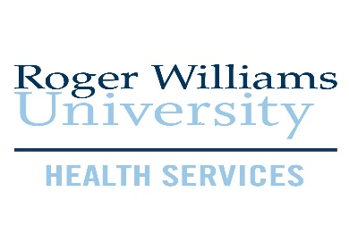
Instructions for accessing and uploading health forms:
All health forms, immunization records, and medical/religious exemption request forms must be submitted electronically in the Health Services Patient Portal. Please do not mail, fax or email health forms.
- To access the Health Services Patient Portal, log in to Roger Central at http://rogercentral.rwu.edu/ ; select Academics > Student Planning > Health Services Patient Portal in the drop-down menu.

- In the patient portal, click on the Forms tab to access required health forms. The Health History and TB Risk Screening forms are completed electronically. The Emergency Contact form must be printed out, completed, and uploaded in the Upload tab

- Submitting the immunization record and COVID-19 vaccine card is a 2-step process:
Step 1 - Click on the Immunization tab and manually enter each vaccination date
Step 2 - Click on the Upload tab, scroll to the bottom and select
immunization record option in the drop-down.

- The following forms must be uploaded:
- Emergency Contact and Consent
- Immunization Record (Note: you do not have to use the immunization form provided in the portal, you can submit an immunization record from your health care provider)
- COVID-19 vaccine card – upload this form under ‘immunization record’ option in the drop-down (Note: there is no COVID-19 specific document option)
- Physical Exam (Note: you can use the physical exam form provided by your health care provider)
- COVID-19 Vaccine Exemption Request if indicated
COVID-19 Vaccine Exemption Request:
Students who, for medical or religious reasons, decline to get the COVID-19 vaccine must submit the RWU COVID-19 Vaccine Exemption Request form by July 7, 2021. Medical exemption requests must be completed and signed by the student’s medical provider. Upload this form under ‘immunization record’ option in the drop-down. Students will be notified of exemption approval status on or before July 16, 2021.
RWU Student Health Insurance:
All students are automatically enrolled in and billed for the RWU student health insurance plan. If a student is already covered under a comparable health insurance plan, they can waive the University plan. To waive, go to https://www.universityhealthplans.com/secure/waiver.cgi?group_id=392 and select Waiver Form from the menu. The deadline to waive is August 15th. If you do not waive by the deadline, you are assuming full-responsibility for paying the annual premium of $2,321. Before waiving the University insurance plan, please review your existing policy to ensure you are covered for medical care in Rhode Island.

Contact Health Services at 401-254-3156 or health@rwu.edu if you need further assistance.

