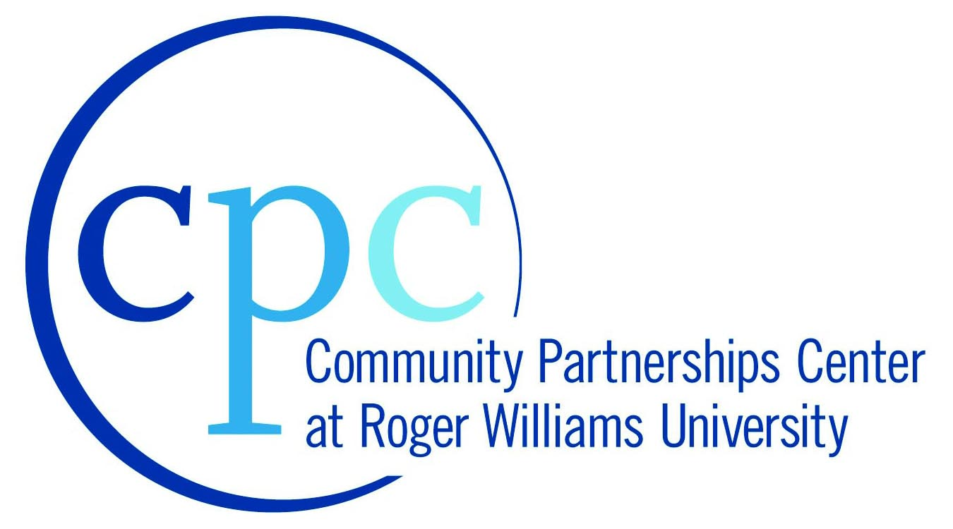
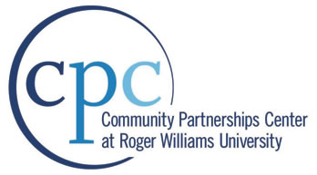

WHAT IS THE RWU COMMUNITY PARTNERSHIPS CENTER?
The Roger Williams University (RWU) Community Partnerships Center (CPC) provides project-based assistance to nonprofit organizations and government agencies in communities in Rhode Island and Southeastern Massachusetts. Our mission is to undertake and complete projects that will benefit the local community while providing RWU students with experience in real-world projects that deepen their academic experiences.
CPC projects draw upon students and faculty from RWU programs in areas such as:
- Accounting  - Architecture  - Business  - Communication  - Community Development  - Construction Management  - Digital Media  - Education  - Engineering  - Environmental science and sustainability  - Finance  - Graphic Design  - History & American Studies | - Historic preservation  - Justice studies  - Law  - Management  - Marketing  - Political Science  - Psychology  - Public Administration  - Public Relations  - Urban Design  - Visual Arts  - Web Development  - Writing Studies

The Center has completed projects ranging from; market research and planning, historical research, mill redevelopment feasibility studies, urban policy analysis, design projects for affordable housing and education facilities, community business district revitalization, neighborhood revitalization plans, museum exhibit design, historic building rehabilitation studies, social services research, website and graphic design, environmental sustainability planning, and survey development.

CPC project services are performed by students in support of their educational experience. Applicants shall understand that any deliverables generated through an accepted project are intended to provide conceptual information only to assist in design and planning and as such are not intended, nor should they be used for, construction or other project implementation. Professional and/or other services may be needed to ultimately implement a sponsor’s desired goals.
HOW CAN YOUR ORGANIZATION PARTNER WITH THE RWU CPC?
As we prepare for upcoming semesters, we are seeking new projects that can benefit local communities while providing our student/faculty teams with opportunities to apply their learning, engage the community, and create final products that provide benefits to all.
Applications will be accepted on an ongoing basis and held for consideration until scheduled CPC Review Committee meetings - generally held in early May and early October. Projects may be considered for upcoming spring, summer and fall academic semesters.
Every effort will be made to process applications that are received in a timely manner prior to the next CPC Review Committee Meeting. Please note it may take between 90-120 days to decide on applications following the initial CPC Review Committee meeting. This time allows us to find the best fit for project requests within courses, programs, and leadership organizations at the University.

CONTACT INFORMATION:
Mia B. Brum
Project Coordinator
mbrum@rwu.edu
401-254-5217

RWU Community Partnerships Center
Roger Williams University, One Old Ferry Road, Bristol, RI 02809-2921 | Website: http://cpc.rwu.edu

Application for CPC Project Assistance
Instructions: We encourage non-profit organizations and municipal agencies to contact the CPC with ideas for projects that can benefit the community while providing meaningful service-learning for RWU students. Please fill out the Application for Project Assistance, answering all applicable questions and including all supporting documents.
Applications will be accepted on an ongoing basis and held for consideration until scheduled CPC Review Committee meetings - generally held in early May and early October. Projects may be considered for upcoming spring, summer and fall academic semesters.

Email: mbrum@rwu.edu
Fax: (401) 254-3523
Mail: RWU Community Partnerships Center
Roger Williams University
One Old Ferry Road
Bristol, RI 02809-2921

Any questions regarding the application process can be directed to Arnold at (401) 254-3307.

CPC project services are performed by students in support of their educational experience. Applicants shall understand that any deliverables generated through an accepted project are intended to provide conceptual information only to assist design and planning and as such are not intended, nor should they be used for, construction or other project implementation. Professional and/or other services may be needed to ultimately implement a sponsor’s desired goals.

SECTION 1: Organization Information

Name of Organization:

Mailing Address:

Name of Project Contact Person(s):

Contact Information:
Phone: Fax:
E-mail:

Type of Organization
- Public (town, city, municipality, special district, government agency)
- Private (citizen, non-profit)
- Other (please explain)

Description of Organization and Mission:

On average, how many individuals does your organization serve per year?

How did you hear about the CPC?

SECTION 2: Project Description

Title of the Project:

Project Location (Address, City, State, and Zip):

General Project Description (you may attach a longer narrative if necessary):

Potential Scope of Work/Tasks for RWU CPC(you may attach a longer narrative if necessary):

What will be the final product output for this project? (survey, website, design plans, drawings, etc.)

Proposed Project Schedule (when the tasks/project needs to be completed):

Please provide the names and contact information for any staff members or volunteers who will be playing a primary role in the proposed CPC project.

What resources/previous work would the CPC be building upon that you already have completed? (Please select all items that are applicable)
- Strategic Plan
- Marketing & Communication Plans
- Additional organizational documents
- Preliminary photos of the site/project
- Maps
- Previous research
- Survey results
- Architectural or building plans

What active support would your organization be able to contribute should your project be selected?

- Funding
- Volunteers
- Staff time
- Consultants
- Other (please list)

SECTION 3: Project Outcomes

Please describe how this project will benefit your organization and the advancement of your mission:

Please describe how this project might benefit the overall community, including specific groups that could benefit from this project (i.e. target populations, neighborhoods, specific town/city/region).

Please explain why you have chosen to seek assistance from the RWU CPC with your project request, instead of undertaking the project using fee-for-services from a paid professional:

Please describe how this project will benefit RWU students.

SECTION 4: Financial Information

What is your organization’s annual operating budget? Please include a copy of your most recent budget with the application.

What are your major sources of funding?

How much funding from your annual operating budget is set aside for this project (if any)?

SECTION 5: Private Sector Involvement

Have you or your organization discussed the project with practicing professionals (e.g. architect, engineer, planner, consultants, etc.)? (please circle one): Yes / No

If no, please explain why:

SECTION 6: Supporting Documents

Please include the following items when submitting your application:
- Budget for the current fiscal year
- List of current Board members
- Copies of supporting resources identified in section 2 as needed to support your application

CPC project services are performed by students in support of their educational experience. Applicants shall understand that any deliverables generated through an accepted project are intended to provide conceptual information only to assist design and planning and as such are not intended, nor should they be used for, construction or other project implementation. Professional and/or other services may be needed to ultimately implement a sponsor’s desired goals.

