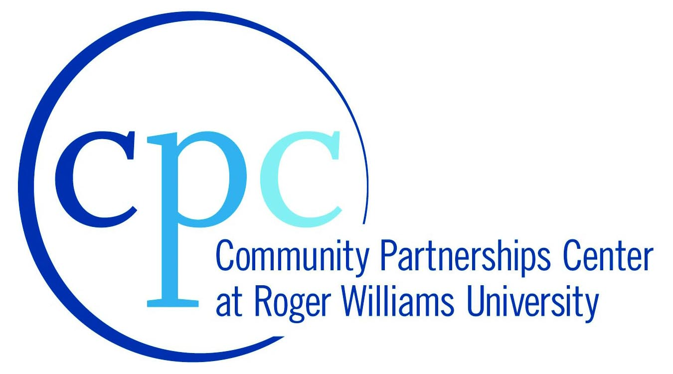
Rhode Island Economic Development Corporation (RIEDC)
Roger Williams University Community Partnerships Center (CPC)

City of Providence, R.I.

Overview
RIEDC, as part of its economic development mission and in partnership with the Office of the Governor of the State of Rhode Island, supports targeted economic development and community building initiatives within the five core communities of Providence, Woonsocket, West Warwick, Pawtucket and Central Falls. The RWU CPC will partner with RIEDC and with local elected officials and community leaders to formulate and support academic programs consistent with the problem-solving interests of the RIEDC and the core communities. In Providence, RWU will assist local revitalization efforts on Broad Street in the South Providence and Elmwood neighborhoods while providing a setting in which students may gain “real-world” technical experience through ongoing curriculum-based projects.

City of Providence: Progress to Date
Through three academic courses – Historic Preservation Planning, Small Business Institute and Crime Prevention – an interdisciplinary team of CPC students and faculty created a Revitalization Vision Plan for Providence’s Washington Park neighborhood and presented that plan to community leaders, local residents and officials from RIEDC. The plan offered research, information and recommendations for community members to undertake a full-scale revitalization effort following the approach outlined by the National Trust for Historic Preservation’s Main Street program.

City of Providence: Phase 1 – Fall 2012
Through the Small Business Institute course at RWU, two senior business students will assist community groups in the Washington Park neighborhood, particularly along Broad Street. Students and faculty will reach out to locally-owned businesses.
- Objective: To provide information on existing programs to assist business owners to strengthen their own enterprises, solicit opinions on needed services and programs, identify and support community business leaders and identify opportunities for support and collaboration. Based on the needs of the local businesses, the students will be deployed to assist business owners in such areas as social marketing, website development, product positioning strategies, accounting and capitalization needs.
- Outcome/Deliverable: In December 2012, the student and faculty team will report on their findings from their work in the field, and make recommendations for areas where RWU assets can be expanded and maximized in order to support local businesses in the coming years.

City of Providence: Phase 2 – Spring 2012
Based on the outcomes from the work in Fall 2012 and the needs identified by the communities and the State, RWU will continue its work in collaboration with local partner organizations and agencies, using:
- Up to two academic courses fully engaged in the RIEDC project (Business Special Topics; Urban Design)
- Up to two academic courses partially engaged in RIEDC project (Community Development; Course TBD)
- Two graduate assistants tasked to project coordination/support
- Two senior business school interns focused on direct business support to local organization

City of Providence: Phase 3 – Summer 2012
Based on the outcomes from the work in Fall 2012 and Spring 2013 as well as the needs identified by the communities and the State, RWU will continue its work in collaboration with local partner organizations and agencies, using:
- An Urban Redevelopment special topics class to be fully engaged in the RIEDC project
- A four-person team of students from the Small Business Institute course
- Two graduate assistants tasked to project coordination/support
- One senior business school intern focused on direct business support to local organization

