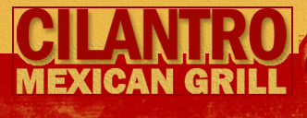

Cilantro Mexican Grill is offering a great deal to RWU students, faculty and staff!

BOGO Wednesdays: Buy One, Get One Free Burrito, with the purchase of a beverage. 3pm-close.

Address 127 Weybosset Street, Providence, RI
Phone (401) 421-8226
ONLINE: www.cilantromex.com

