## ADP Time & Attendance: Timestamp/Hourly-View Timecard

If you are a timestamp employee, your time-entry method will look like the following example.

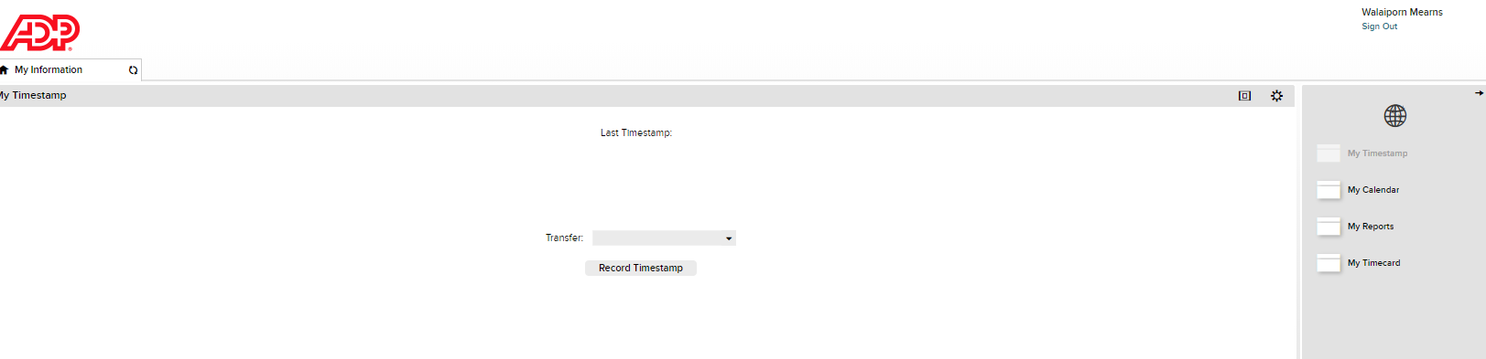Let’s take a look at the various tasks associated with this time-entry method.

ADP Time & Attendance: Timestamp/Hourly-View Timecard 1

Enter Time 2

Transfer Time 4

Cancel a Meal Deduction 5

Add a Pay Code 6

View Accrual Balances 9

View Totals 10

Approve Your Timecard 11

Remove a Timecard Approval 13

## Enter Time

When you log in to ADP Time & Attendance, you see your default workspace, which includes the My Timestamp widget.

**Starting Point: My Information > My Timestamp**

| Step | Action |
| --- | --- |
| 1 | Click **Record Timestamp** to record your start and end times. |
|  | Your recorded start time is displayed. |

| Step | Action |
| --- | --- |
| 2 | If you have access to your timecard, click **Refresh** to view recorded time within your timecard. |

## Transfer Time

Your manager may require you to transfer temporarily to a different department or job. You can perform a labor account transfer to record this transaction on your timecard.

**Starting Point: My Information > My Timestamp**

|  |  |  |
| --- | --- | --- |
| Step | Action | |
| 1 | Select **Transfer**. | |
| 2 | Click **Search**.  **Note:** You may see additional selections if your company has set them up for you, or if you have previously accessed a labor account. | |
| 3 | In the **Select Transfer** window, select the appropriatelabor account from the available fields. Ask your manager for the information you need to complete the transfer.  **Note:** Your company determines which items are displayed in the Select Transfer window. |  |
| 4 | Click **OK**. | |
| 5 | Click **Record Timestamp** to punch in using the new labor account. | |

## Cancel a Meal Deduction

Occasionally, it may be appropriate for you to cancel your meal deduction. For example, if you work through lunch. The following steps show you how to accomplish this.

**Starting Point: My Information > My Timestamp**

|  |  |
| --- | --- |
| Step | Action |
| 1 | Select **Cancel Deductions**. |
| 2 | Click **Record Timestamp** to punch out. |

## Add a Pay Code

If you are sick, on vacation, or leave work early, you may be required to record your time on your timecard. For example, if you work from 8:00 a.m. until 12:00 p.m., and then take the rest of the day as sick time, you can add a row to add your sick time. The following steps show you how to accomplish this task.

**Starting Point: My Information > My Timestamp**

| Step | Action |
| --- | --- |
| 1 | Click **Record Timestamp** to record your end time. |
|  | Your recorded end time is displayed. |

## View Accrual Balances

When you want to see how much time off you have accrued, you can access the balances from your timecard.

**Starting Point: My Information > My Timecard**

| Step | Action |
| --- | --- |
| 1 | Select the appropriate date in the timecard to view the accruals as of a particular date. |
| 2 | Click the **Accruals** tab. |
| 3 | View your accrual balances.    **Note:** Your accrual balances may vary based on the date you select on your timecard. |

## View Totals

You can view the total hours you have worked from your timecard.

**Starting Point: My Information > My Timecard**

| Step | Action |
| --- | --- |
| 1 | Select the appropriate pay period. |
| 2 | If necessary, click the **Totals** tab at the bottom of the timecard. This tab is available by default. |
| 3 | View your timecard totals for the selected pay period.    **Note:** You can view the totals by account or by pay code. You can also filter the totals by a range of time, such as daily, period to date, or shift. |

## Approve Your Timecard

You may be required to approve your timecard at the end of the pay period. You should view and approve your timecard to avoid pay discrepancies and ensure timecard accuracy.

**Starting Point: My Information > My Timecard**

| Step | Action |
| --- | --- |
| 1 | Select the appropriate pay period. |
| 2 | Click **Approve Timecard**. |

| Step | Action |
| --- | --- |
| 3 | Select **Approve** **Timecard**.    After you approve your timecard, a message is displayed indicating that your timecard has been approved and an orange visual indicator is displayed on the timecard.    **Note:** The following provides you with the meaning of the visual timecard color indicator.   * Orange: employee approval * Yellow: manager approval * Green: employee and manager approval * Gray: signed off |

## Remove a Timecard Approval

If you need to make a change on your approved timecard, you must first remove the approval.

**Starting Point: My Information > My Timecard**

| Step | Action |
| --- | --- |
| 1 | Click **Approve Timecard**.    **Note:** Once your manager approves your timecard, you cannot remove the approval and edit your timecard. Notify your manager if you have updates to your timecard. |
| 2 | Select **Remove Timecard Approval**.    After you remove the timecard approval, a message is displayed indicating that your timecard approval has been removed. |
| 3 | Make the appropriate updates to your timecard. |
| 4 | Click **Save**. |
| 5 | To approve your timecard again, click **Approve Timecard** and select **Approve Timecard**. |

|  |
| --- |
| **Credits**  The ADP® logo and ADP® letters are registered trademarks of ADP, LLC. In the Business of Your SuccessSM is a service mark of ADP, LLC.  All other trademarks and service marks are the property of their respective owners.  Copyright © 2015 ADP, LLC. ADP Proprietary and Confidential - All Rights Reserved. These materials may not be reproduced in any format without the express written permission of ADP, LLC.  ADP provides this publication “as is” without warranty of any kind, either express or implied, including, but not limited to, the implied warranties of merchantability or fitness for a particular purpose. ADP is not responsible for any technical inaccuracies or typographical errors which may be contained in this publication. Changes are periodically made to the information herein, and such changes will be incorporated in new editions of this publication. ADP may make improvements and/or changes in the product and/or the programs described in this publication at any time without notice. |