ADP Time & Attendance: Time-Off Requests
Depending on your organization’s configuration, you may have access to request time off through ADP Time & Attendance. Time-off requests can be configured to require approval by a manager, or be approved automatically.
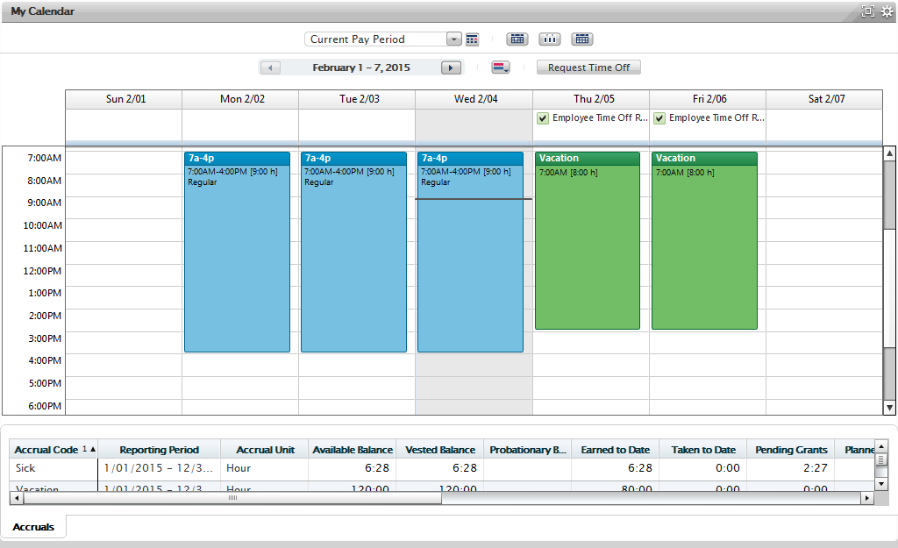
Let’s take a look at the various tasks associated with time-off requests.
Navigate to My Calendar 2
Submit a Time-Off Request (Hours) 3
Submit a Time-Off Request (Half Day or Full Day) 4
Submit a Time-Off Request with Multiple Time-Off Periods 6
Retract a Pending Time-Off Request 8
Cancel an Approved Time-Off Request 9
Create a Draft Time-Off Request 10
Submit a Draft Time-Off Request 11
Delete a Draft Time-Off Request 12
View the Status of a Time-Off Request 13

Navigate to My Calendar
In the My Calendar widget, you can view your schedule , request time off, and view the status of your time-off reqeusts. Follow the steps below to access the My Calendar widget.
Starting Point: My Information
Step | Action
1 | Click the gear icon () and select Pop-Out.  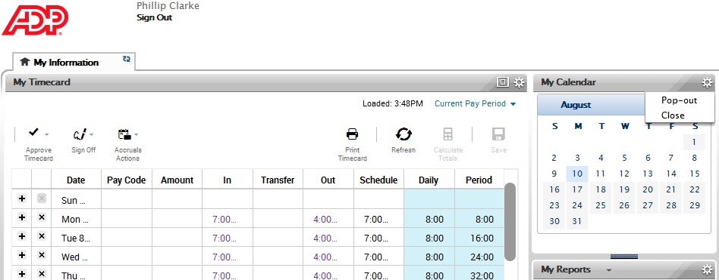
2 | Click the resize button () to maximize the My Calendar widget.  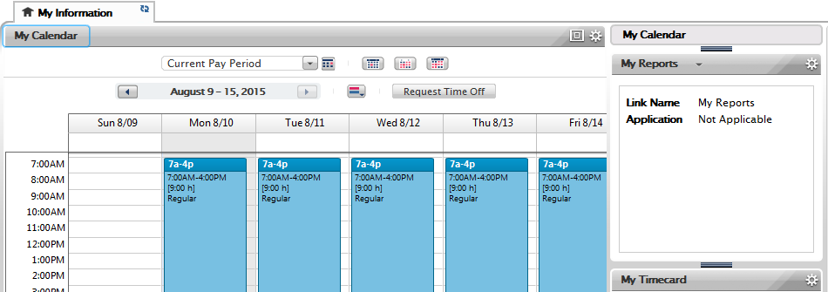
3 | Use the My Calendar widget to view your schedule and manage your time-off requests.  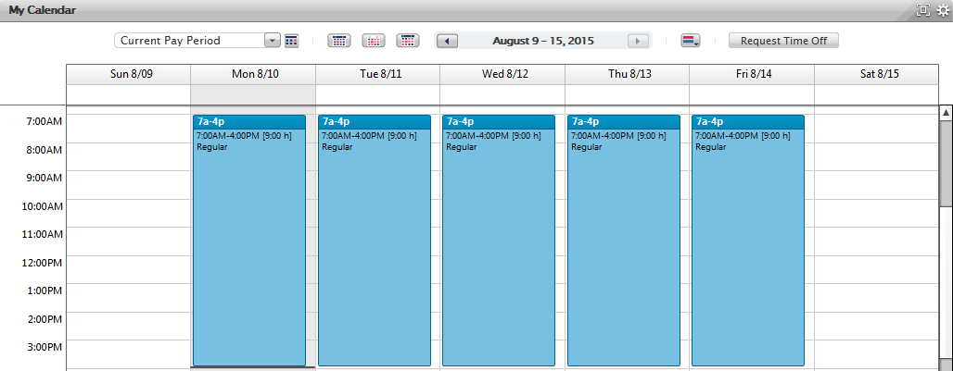

Submit a Time-Off Request (Hours)
To submit a time-off request to your manager, access the My Calendar widget. If you select the Hours as the duration for your time-off request, you need to enter the start time and length of your time-off request.
Starting Point: My Information > My Calendar
Step | Action
1 | Select the appropriate pay period.
2 | Click the Request Time Off button.
3 | In the Request Time Off window, complete the following:  - In the Start Date field, enter the first day of the request.  - In the End Date field, enter the last day of the request.  - In the Pay Code field, select the appropriate pay code.  - In the Duration field, select Hours.  - In the Start Time field, enter a start time for the request.  - In the Length field, enter the length of the request in hours per day.  - In the Notes field, enter any additional information about this request.
4 | Click Submit.  The request is sent to your manager for approval.

Submit a Time-Off Request (Half Day or Full Day)
To send a time-off request to your manager, access the My Calendar widget. You can use the half- and full-day durations to replace your scheduled shift.
Starting Point: My Information > My Calendar
Step | Action
1 | Select the appropriate pay period.
2 | Click the Request Time Off button.
3 | In the Request Time Off window, complete the following:  - In the Start Date field, enter the first day of the request.  - In the End Date field, enter the last day of the request.  - In the Pay Code field, select the appropriate pay code.  - In the Duration field, select Full Day, 1st Half Day, or 2nd Half Day. (You are not required to enter a start time or a length of time).  - In the Notes field, enter any additional information about this request.
4 | Click Submit.  The request is sent to your manager for approval.

Two Halves Do Not Make a Whole
Scenario: An employee has a shift 8:00 a.m. to 5:00 p.m. with a one-hour meal break. The employee asks for the first half of the day off. He submits a time-off request and receives approval for the first half of his shift off. Then, he decides he would like the whole day off.
He submits a request for the second half of the day. ADP Time & Attendance will act upon the remaining four-hour shift (1:00 p.m. - 5:00 p.m.). Half of that shift is two hours. The employee has from 8:00 a.m. to 12:00 p.m. and from 3:00 p.m. to 5:00 p.m. off.
Best Practice: You will need to cancel the half-day time-off request and resubmit as a full-day time-off request.

Submit a Time-Off Request with Multiple Time-Off Periods
To send a time-off request with multiple time-off periods to your manager, access the My Calendar widget.
If you request time off around a weekend and you are not regularly scheduled to work weekend days, you will need to submit a request with multiple time periods: one time-off period for the days before the weekend and one time-off period for the days after.
Starting Point: My Information > My Calendar
Step | Action
1 | Select the appropriate pay period.
2 | Click the Request Time Off button.
3 | In the Request Time Off window, complete the following:  - In the Start Date field, enter the first day of the request.  - In the End Date field, enter the last day of the request.  - In the Pay Code field, select the appropriate pay code.  - In the Duration field, select Hours, Full Day, 1st Half Day, or 2nd Half Day.  - If Hours was selected in the Duration field, enter a start time and a length of time in the appropriate fields.  - In the Notes field, enter any additional information about this request.
4 | To add another time-off period, click Add Another Time-Off Period.
5 | For the second time-off period, complete the available fields (repeat step 3). It is best practice to use only one pay-code type per time-off request.  Note: To remove a time-off period, click the X next to the time-off period row.
6 | Repeat steps 4 and 5 for each additional time-off period.
7 | Click Submit.  The request is sent to your manager for approval.

Retract a Pending Time-Off Request
You can retract the entire time-off request if your manager has not taken action on the request. Let’s take a look at how to retract a time-off request that has not been approved by your manager.
Starting Point: My Information > My Calendar
Step | Action
1 | Point to your pending time-off request and click the arrow.
2 | Select Retract.  Note: To view the specifics for this time-off request, select Details.
3 | In the Retract Time-Off Request window, confirm the retraction and click Submit.  The request is removed from your manager’s view.

Cancel an Approved Time-Off Request
Let’s take a look at how to cancel a time-off request that has been approved by your manager.
Starting Point: My Information > My Calendar
Step | Action
1 | Point to your approved time-off request and click the arrow.
2 | Select Cancel.  Note: To view the specifics for this time-off request, select Details.
3 | The Cancel Time-Off Request window is displayed.  In the Notes field, enter any additional information regarding the cancellation.
4 | Click Submit.  A cancellation time-off request is sent to your manager for approval.

Create a Draft Time-Off Request
Let’s take a look at how to create a draft time-off request.
Starting Point: My Information > My Calendar
Step | Action
1 | Select the appropriate pay period.
2 | Click the Request Time Off button.
3 | In the Request Time Off window, complete the following:  - In the Start Date field, enter the first day of the request.  - In the End Date field, enter the last day of the request.  - In the Pay Code field, select the appropriate pay code.  - In the Duration field, select Hours, Full Day, 1st Half Day, or 2nd Half Day.  - If Hours was selected in the Duration field, enter a start time and a length of time in the appropriate fields.  - In the Notes field, enter any additional information about this request.
4 | To add another time-off period, click Add Another Time-Off Period and complete the available fields (repeat step 3).
5 | Click Draft.  The request is saved in your calendar and is not sent to your manager.

Submit a Draft Time-Off Request
Let’s take a look at how submit a draft time-off request.
Starting Point: My Information > My Calendar
Step | Action
1 | Point to your draft time-off request and click the arrow.
2 | Select Submit.  Note: To view the specifics for this time-off request, select Details.
3 | In the Submit Time-Off Request window, confirm the time-off request and click Submit.  The request is sent to your manager for approval.

Delete a Draft Time-Off Request
Let’s take a look at how to delete a draft time-off request that has not been sent to your manager.
Starting Point: My Information > My Calendar
Step | Action
1 | Point to your draft time-off request and click the arrow.
2 | Select Delete.  Note: To view the specifics for this time-off request, select Details.
3 | In the Delete Time-Off Request window, confirm the deletion and click Delete.  The request is removed from your calendar.

View the Status of a Time-Off Request

Notification
Depending on your manager’s action regarding your time-off request, you will receive a notification for the approval, refusal, or retraction of your time-off request. These notifications are displayed in your Inbox. If your manager has put the time-off request in a pending state, you will be notified that the request has been acknowledged, but the final decision has not been made.

Approved Time Off
If your manager approved your time-off request, the time off is displayed in your timecard.
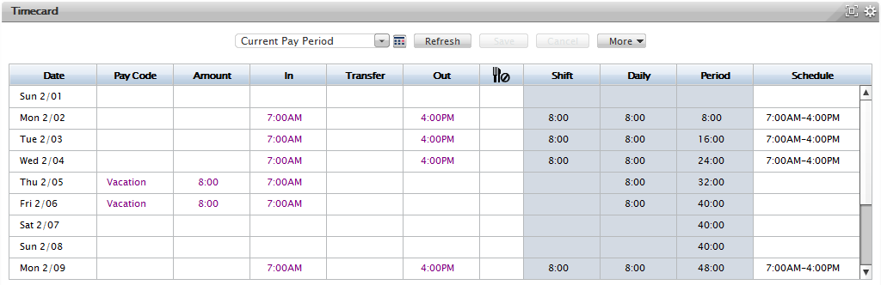
In addition, your approved time off is displayed on your calendar as blocked time.

Status
You can view the status of your time-off request in the My Calendar widget. Point to the time-off request status to view the tool tip for more information.
Let’s review the various status indicators available for a time-off request.
Status Indicator | Description
 | Your time-off request or your time-off request cancellation is sent to your manager.
 | Your manager approved your time-off request or your time-off request cancellation.
 | You retracted your pending time-off request.
 | You saved your time-off request as a draft.
 | Your manager refused your time-off request.

Accrual Balances
In the Request Time-Off window, you can view your accrual balances. To view your accrual balances for a different date, update the Accruals On field.

If you try to submit a time-off request and you do not have enough hours in your accrual balance, you will receive an error message.

Credits
The ADP® logo and ADP® letters are registered trademarks of ADP, LLC. In the Business of Your SuccessSM is a service mark of ADP, LLC.
All other trademarks and service marks are the property of their respective owners.
Copyright © 2015 ADP, LLC. ADP Proprietary and Confidential - All Rights Reserved. These materials may not be reproduced in any format without the express written permission of ADP, LLC.
ADP provides this publication “as is” without warranty of any kind, either express or implied, including, but not limited to, the implied warranties of merchantability or fitness for a particular purpose. ADP is not responsible for any technical inaccuracies or typographical errors which may be contained in this publication. Changes are periodically made to the information herein, and such changes will be incorporated in new editions of this publication. ADP may make improvements and/or changes in the product and/or the programs described in this publication at any time without notice.

