ADP Time & Attendance: General Tasks
Use the step-action tables in this job aid to perform the following tasks:
Find an Employee Using QuickFind 2
Find an Employee Using Search 4
Find a Group of Employees Using Search 6
Access Online Help 8

Find an Employee Using QuickFind
Use the QuickFind widget to search for a particular person or set of people based upon a name or ID.
Starting Point: Manage My Employees > Manager Links > QuickFind
Step | Action
1 | In the Search field, enter the last name of the employee or leave the default asterisk to view all employees. You can also search by the employee’s ID number.  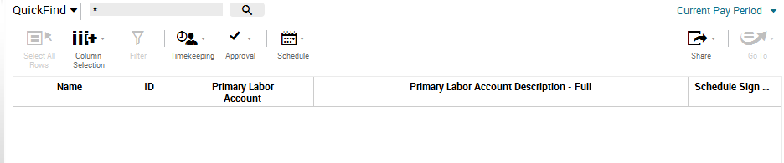  Tip: You can search for names using one or more characters with the asterisk.
2 | To change the time period, click the blue text, select the appropriate time period, and then click Apply.  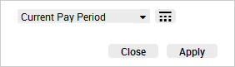
3 | Click the magnifying glass button. The search results are displayed.  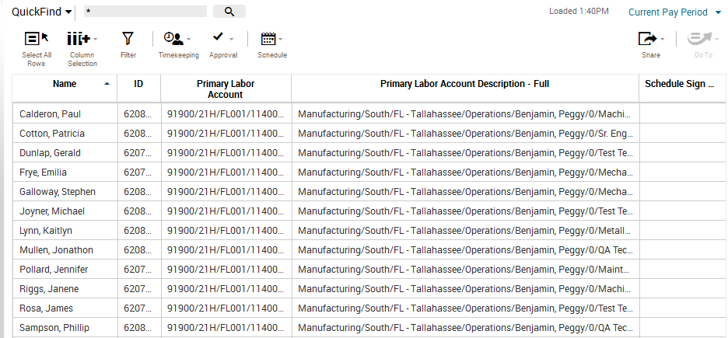  Tip: To access your employees’ timecards, select the employees’ names, click Go To, and then select Timecards.
Tips for selecting multiple employees are as follows:
- Select all employees: Click Select All Rows.
- Select multiple employees: Press the Ctrl key and select individual employees.
- Select a group of employees: Select the first name in the list, press the Shift key, and then select the last employee in the list. All employees between the first name and last name will be selected.

Find an Employee Using Search
Use the Search workspace to search for a particular person. This option will only work for managers with less than 1,000 employees.
Step | Action
1 | Click the magnifying glass icon to access the Search workspace.  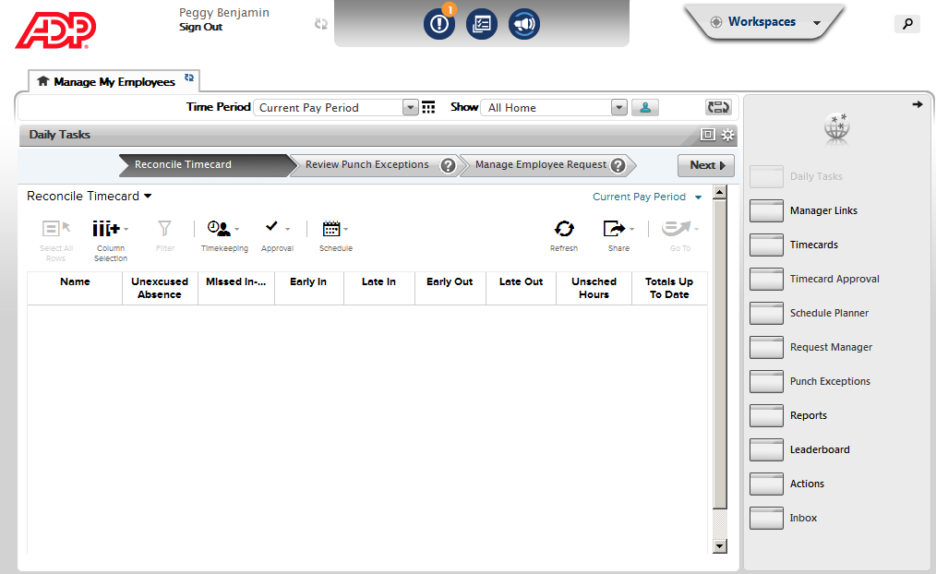
2 | Begin the search by entering the first three characters of the employee’s last name.  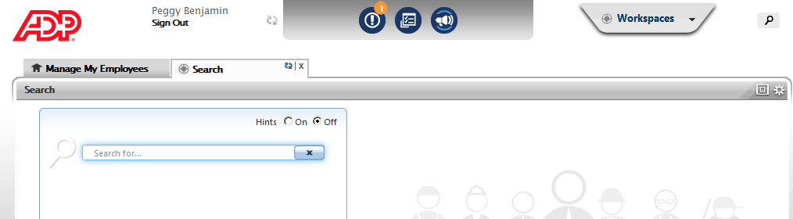
3 | From the search results, select the employee’s name.  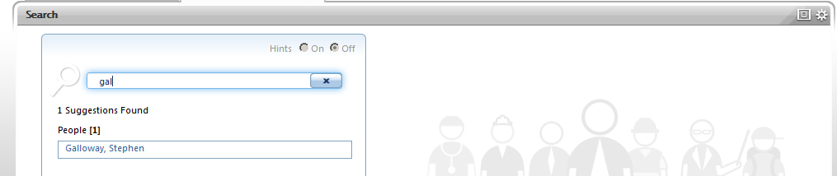
4 | Review the employee’s information in the right pane.  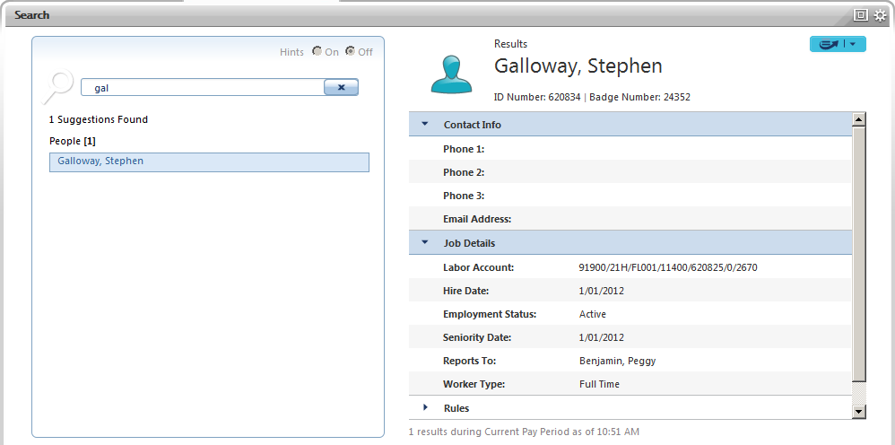
5 | If necessary, click the Go To icon to access a widget or workspace for the selected employee.  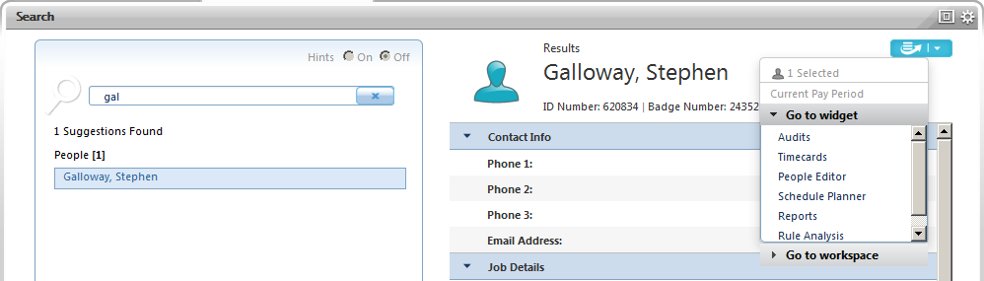

Find a Group of Employees Using Search
Use the Search workspace to search for a group of employees by searching for a time data element, such as pay rules or employee groups.
Step | Action
1 | Click the magnifying glass icon to access the Search workspace.
2 | Begin the search by entering the first three characters of your search query to display suggestions or turn the hints on to display a search list.

Step | Action
3 | From the search results, select the appropriate entry.  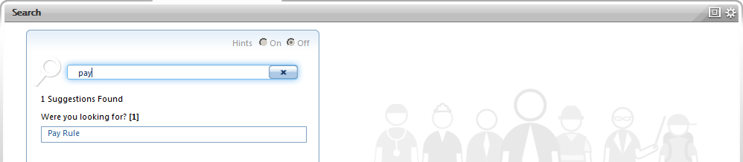
4 | Review the employees in the right pane.  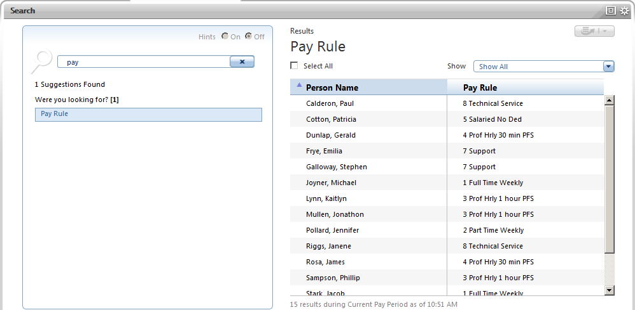
5 | If necessary, select the appropriate employees and click the Go To icon to access a widget or workspace for the selected employees.  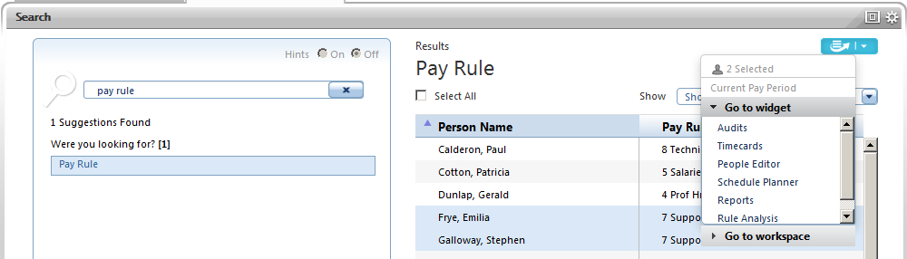

Access Online Help
Online Help provides content and key term searches. Many search results provide links to related topics for further exploration of a topic.
Starting Point: Manage My Employees
Step | Action
1 | On the Workspaces carousel, click General Maintenance.
2 | In the Related Items pane, select Help.
3 | Select the appropriate category and topic in the left pane.  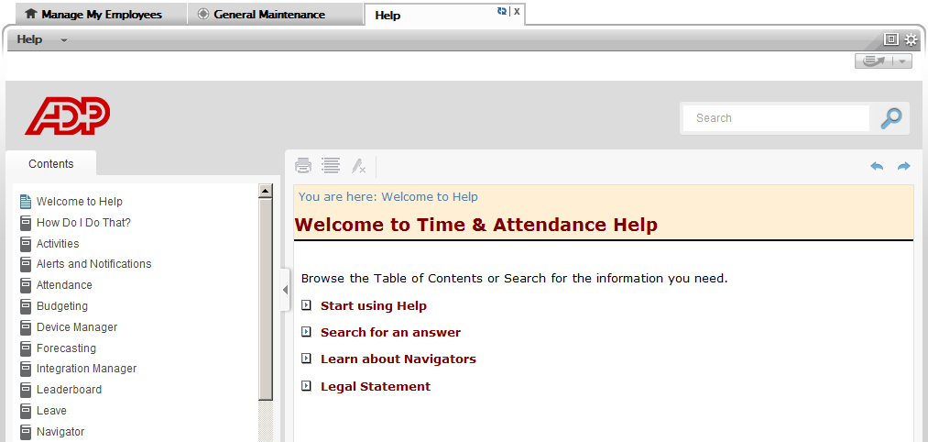  Tip: Use the Search field to locate topics by a specific word or phrase.
Credits
The ADP® logo and ADP® letters are registered trademarks of ADP, LLC. In the Business of Your SuccessSM is a service mark of ADP, LLC.
All other trademarks and service marks are the property of their respective owners.
Copyright © 2015 ADP, LLC. ADP Proprietary and Confidential - All Rights Reserved. These materials may not be reproduced in any format without the express written permission of ADP, LLC.
ADP provides this publication “as is” without warranty of any kind, either express or implied, including, but not limited to, the implied warranties of merchantability or fitness for a particular purpose. ADP is not responsible for any technical inaccuracies or typographical errors which may be contained in this publication. Changes are periodically made to the information herein, and such changes will be incorporated in new editions of this publication. ADP may make improvements and/or changes in the product and/or the programs described in this publication at any time without notice.

